Hours of Operation Worksheet Library/Branch Location: ______________________
Spring 2008

1. Generally, Our Opening/Closing Times Are:
Monday | Tuesday | Wednesday | Thursday | Friday | Saturday | Sunday
Ex. 8am -5pm

2. Exceptions: On These Dates, Our Opening/Closing Times Are:
Date | Open/Close | Date | Open/Close | Date | Open/Close | Date | Open/Close
Ex. 2/29 | 8am -7:30

3. We will be CLOSED on these dates (please mark):
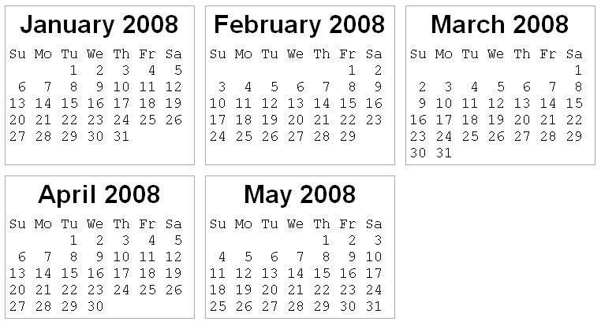

http://www.timeanddate.com/calendar/
(customized; printer-friendly; browser-enlarged text (+2); print screen; paste/crop) ihd

