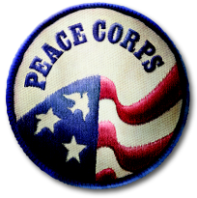
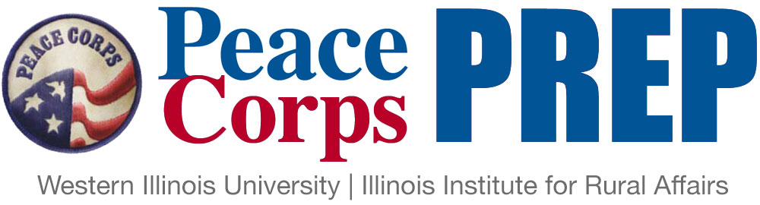

Student Application

Name: ________________________________ Student ID: _____________ Date: __________

Phone: ____________________ Email: _____________________________________________

Major(s): _____________________________ Minors(s): _______________________________

Expected Graduation (month and year): ______________________ Cumulative GPA: ________

- Training and experience in a specific work sector
Please check the box of the sector in which you would like to serve:

- Education
- Health
- Environment
- Agriculture
- Youth in Development
- Community Economic Development

Note: Actual Peace Corps assignments are based on local needs, and thus may or may not align seamlessly with your qualifications. Flexibility is key to the Peace Corps experience!

- Coursework. List the number and name of 3 courses in this sector that you plan to take, and the semester in which you plan to take them (it is fine if you’ve already taken them).
Note: These may change! But it’s good to have a plan.

- Course: _____________________________ Semester and year: _____________________
- Course: _____________________________ Semester and year: _____________________
- Course: _____________________________ Semester and year: _____________________

- Hands-on experience or service in that same sector (must total at least 50 hours).
Describe what you plan to do:

- Foreign language skills
Requirements depend upon desired Peace Corps volunteer placement site. (1) Spanish-speaking countries two 200-level courses. (2) French-speaking countries one 200-level courses in any Romance Language. (3) Everywhere else no explicit requirements, but language skills are a plus.
Language: _______________________
List the top 2 non-English language courses you plan to take:

1. _______________________________
2. __________________________________

Or describe your alternative learning process (e.g., native speaker):

- Intercultural awareness
List the top three approved intercultural courses you plan to take:

- _____________________________
- _____________________________
3. _________________________________

- Professional and leadership development
- Consultation with Career Services: When do you plan to meet with Career Services for a consultation on resume writing, interviewing skills, or other professional skills? Semester and year: ___________________________________________________________
- Professional workshop: Which two PC Prep-approved workshops do you plan to attend? Semester(s) and year: _________________________________________________________
- Describe a leadership experience that you intend to pursue:
For example, leading a work or volunteer project, serving on the executive board of a student organization, or organizing a big campus event.

- Personal statement of interest
On a separate sheet of paper, briefly describe (in 350 – 500 words) why you are interested in participating in the Peace Corps Prep Program at WIU and how it aligns with your future goals.

I understand that acceptance and/or completion of the Peace Corps Prep Program at WIU neither requires me to apply to the Peace Corps, nor does it guarantee acceptance into the Peace Corps.

_____________________________________________________________________________________
Signature of Student Date

