
WIU Chapter - SUAA
Newsletter
Serving the interest of the annuitants and survivors of Western Illinois University
January 2015

OFFICERS AND EXECUTIVE BOARD  2014- 2015  President  Marcia Lucas  Vice President  Jackie Thompson  Past President  Sandra Nelson  Secretary  Jacqlin Richmond  Treasurer  Penelope Yunker  Directors  Frank Fulkerson  Candace McLaughlin  Deckle McLean  Foundation Chair  Michael Pledge  Legislative Chairs  Nick Pano  Charles Gilbert  Newsletter Editor  Gil Belles  Webmaster  Dennis Werling  Membership Chairs Patricia Jones  Karen Helmers  Survivor Assistance Chair  Frances Hedblade  Social Chair  Charlene Callison  SUAAction Representative  Nick Pano  WIU Human Resources Representative  Bill Rupert  WIU-UPI Representative  John Miller  Springfield Liaison  Maurine Magliocco | 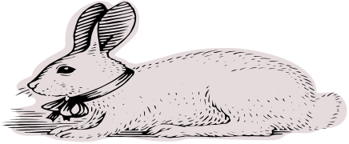  Snow Bunny Luncheon  Noon  Tuesday, February 3, 2015  (snow date Tuesday, February 10)  First Presbyterian Church  400 East Carroll  Macomb, IL  SUAA will provide roasted turkey, rolls and beverages.  SUAA members are to bring their own table service.  Our "speaker" will be  "Nick Pano bringing us up to date with the SUAA legal fight."  SNOW BUNNY LUNCHEON  RSVP by January 29, 2015  Tuesday, February 3, 2015  (snow date Tuesday, February 10)  Noon at First Presbyterian Church  Please bring your own table service and one of the following: Salad/Vegetable/Dessert  I will bring (Circle one): Salad Vegetable Dessert  Name: ___________________________________________________  Number attending: __________________  Respond by January 29 to: Penny Yunker  1901 Riverview Dr  Macomb,IL 61455  837-9119 or Yunker@macomb.com

MESSAGE FROM THE PRESIDENT:
Marcia Lucas

The legal battle continued this fall over the legislated pension changes that had been challenged last year. Even though the Sangamon County Circuit Court ruled that legislation to be unconstitutional, the Attorney General has entered a direct appeal to the Illinois Supreme Court. In spite of this, we will see the cost of living increase of three percent applied in January 2015. The SUAA Board will continue to keep you updated on any new developments. In addition, Nick Pano provides an excellent summary of the current and upcoming legislative issues relevant to our interests.
Your total SUAA dues each year are a combination of state SUAA dues and local (WIU) SUAA dues. Although the state SUAA dues have been increased by $2/member for the upcoming calendar year 2015, your total dues for 2015 will NOT be raised. At this time, your WIU/SUAA Board of Directors decided to offset the state dues increase by lowering local dues by the same amount for 2015.
We hope you will join us at the Snow Bunny Luncheon on Tuesday, February 3, at the First Presbyterian Church in Macomb. Be sure to send in the reservation on the front page indicating whether you'll be bringing a salad, vegetable or dessert in addition to your own table service. At the luncheon, we will hear updates on both the Macomb Library and the SUAA pension, insurance, and legislative issues.

NICK’S AWARD

On September 28, in New York City, the President of the Republic of Albania, Bujar Nishani, awarded Nick Pano the prestigious "Nderi i Kombi" Medal. At its November meeting your local WIU-SUAA board congratulated Pano, retired history professor, former associate dean of the College of Arts and Sciences, and legislative co-chair of our chapter. Social chair Charlene Callison had a cake in Albanian colors awaiting Pano when he walked in. Pano is a specialist in Albanian history and politics, and has worked on behalf of democratic development in that country.

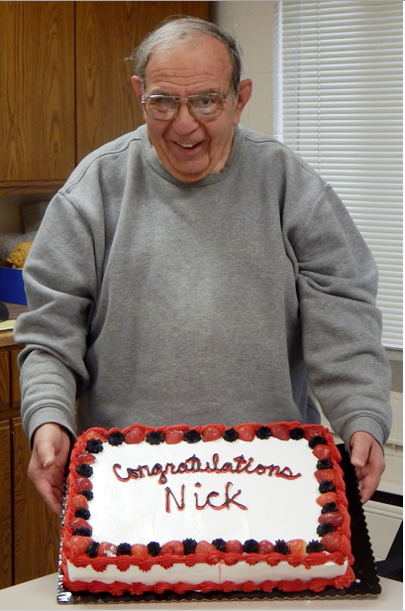

LEGISLATIVE UPDATE
Nick Pano

Outgoing Governor Pat Quinn called a special session of the General Assembly for January 8, 2015 to deal with filling the office of State Comptroller arising from the death of Judy Barr Topinka.
Bruce Rauner, the first Republican to hold the position of Governor since 2003, assumed office on January 12. The first session of the 99th General Assembly convenes on January 14. Democrats will continue to control both the State Senate (39-20) and the House of Representatives (71-47) with super majorities, thus enabling them to control the legislative process on issues on which they agree. Rauner pledged to work cooperatively with House Speaker Madigan and Senate President Cullerton to address the deepening fiscal crisis confronting Illinois.
This situation has been exacerbated by the failure of the General Assembly to extend the temporary state income tax increases approved in 2011. This development will result in a significant drop in state revenue for the final six months of the 2015 fiscal year. And, should this revenue issue not be addressed, it will pose some serious problems in crafting a state budget for FY 2016. The state’s budgetary problems cannot be solely resolved by reductions in expenditures.
During the 2014 gubernatorial campaign, Mr. Rauner had chastised the Quinn administration and the Democratic-controlled General Assembly for passing a FY 15 budget that was in reality badly out of balance. And, following the election, he has repeatedly declared that the state’s fiscal plight is even worse than he had surmised.
Rauner has thus far provided few insights or little specific information as to how he proposes to deal with the “fiscal mess” he has inherited, except to request that state agencies and state-supported entities plan for possible reductions of from 5 to 20 percent in their expenditures for the remainder of the current fiscal year and beyond. It is anticipated that details of the new governor’s budget agendas will be revealed in his January Inaugural and March Budget addresses.
It is within this context that the ongoing litigation regarding our pension and health insurance benefits has been playing out in the courts. In July 2014, the Illinois Supreme Court in the case of Kanerva vs. Weems ruled that the state’s subsidization of health insurance costs for its employees was a benefit under the provisions of the “pension protection clause” of the 1970 Illinois State Constitution. The Court referred the case back to Sangamon County Circuit Court Judge Stephen Nardulli to establish the details for processing the refunds of the health insurance premiums. These refunds should be distributed sometime between March-June 2015.
On November 21, Sangamon County Circuit Judge John Belz declared the so-called “pension reform legislation” (PA 98-0599/SB 1) unconstitutional. This decision prompted an immediate appeal along with a request for an expedited hearing of the case on behalf of the state to the Illinois Supreme Court by Attorney General Lisa Madigan. The legal process on this phase of the case will begin during January 2015 and it is anticipated that oral arguments on this matter will be presented to the Court during March. Although we have reasonable expectations to be optimistic regarding the outcome of the case, a result in our favor may not be the certainty some of our members believe it to be.
Given the mounting legal costs to challenge the state’s appeal, please consider making a contribution to the SUAA Legal Fund by check payable to SUAA Legal Fund sent to: SUAA Legal Fund; c/o SUAA; 217 East Monroe Street; Springfield, IL 62701. For on-line contributions, consult the SUAA website.

MEMBERSHIP UPDATE
Co-Chairs: Patti Jones and Karen Helmers

SURS AND SUAA—What’s the difference?

SURS (State Universities Retirement System) administers benefits that include retirement, survivor, disability, and death benefits for employees of Illinois state universities, community colleges, and certain other affiliated organizations and agencies.
SUAA (State Universities Annuitants Association) advocates for the protection of these benefits.
SUAA actively works to preserve and to protect the SURS pension system, the healthcare plans, and other benefits provided for community college and university employees and retirees, their spouses and survivors. SUAA is not a union.

Why should you and your colleagues join SUAA?

Joining SUAA is a way of taking responsibility for your own future, of doing something now to make sure that your retirement is there when you need it, or hasn't been changed since you began your retirement. If we leave it up to the State, legislation could alter our pension system as we know it. To join, log on to www.suaa.org and send the Membership Form with either a check for $42.00 or the Dues Deduction authorization form to:

SUAA
217 E. Monroe
Suite 100
Springfield, IL 62701

If you have questions concerning membership to SUAA, please contact either: Patti Jones at 727 E. Jackson St. Macomb, IL 61455 or 309-836-8291; or Karen Helmers at 1003 Bayberry Lane, Macomb, IL 61455 or 309-333-4813


Human Resources
State University Annuitants Association Foundation Inc.
1 University Circle
Macomb, IL 61455

