SUPERVISOR CONFIRMATION SCREENS

The CONF option will be used by supervisors to confirm employee(s) time. Office administrators can also use these screens to check the status of the screens for the employees in their department.

To access the screens online, go to http://mvs.wiu.edu/ and click on WIUP in the upper right hand corner of the screen.

The Access Agreement will then be displayed.

Click on “Yes, I agree” and the WIUP Production Sign-on screen will be displayed.

The user should sign in with their userid and password, then click on “sign-on” or press enter.

The NEWS screen will then be displayed. Important messages will be displayed here.

The user can then click on the “CONF: Time Confirmation/Admin Review” tab or type CONF in the “Display” field and press or click on enter.

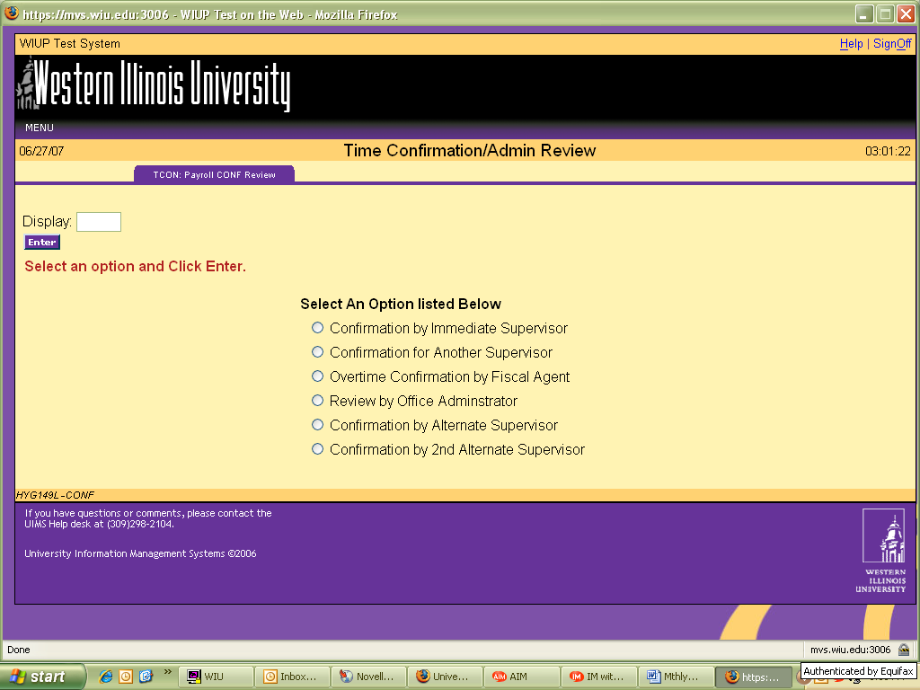

To confirm employee timecard(s), the supervisor should click on the circle next to “Confirmation by Immediate Supervisor.”

The Time Confirmation/Admin Review screen is displayed.

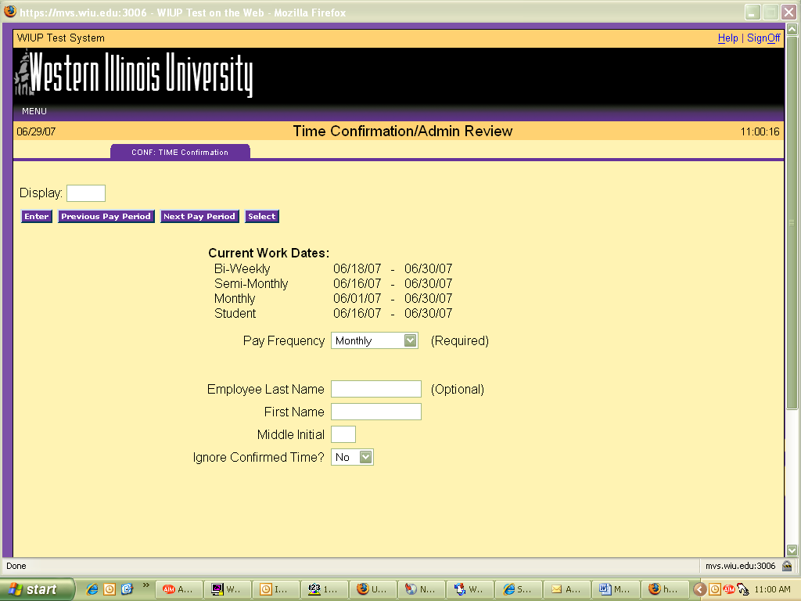

To see the time screens for the current pay period, click on Monthly in the drop down box next to Pay Frequency and click or press enter. To see the time screens for the previous pay period, click on the “Previous Pay Period” box and click or press enter.

To access a specific employee’s screen, the user may enter the employee’s last name then press or click on enter.

The Monthly Time Reporting screen will then be displayed for each of the user’s employees.

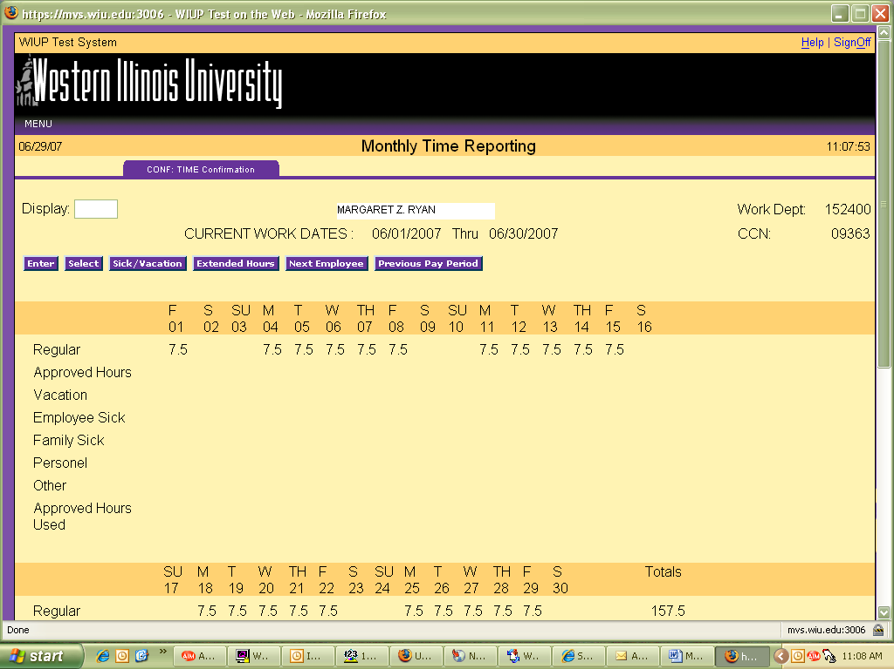

The supervisor should check the hours entered and be sure Employee Confirm is “Yes.” The supervisor cannot confirm the timecard until the employee has confirmed. Once the employee has confirmed, the supervisor can click on the “Yes” in the Supervisor Confirm drop down box and click or press enter. If the timecard has an error, the employee needs to change the hours then reconfirm the card before the supervisor can confirm it. The supervisor cannot make any changes to the hours entered on the employee’s screen. If an employee makes a change to the screen after the supervisor has confirmed it, the “Yes” in the supervisor confirm box will automatically be flipped back to a “No”. The supervisor will then need to reconfirm the screen after the employee has completed his/her changes.

After the supervisor has placed a “Yes” in the drop down box, press or click on enter to update the screen.

If the Error Message EMPLOYEE MUST CONFIRM FIRST appears on the screen, the supervisor has tried to confirm the screen before the employee has confirmed it. The supervisor must change the “Yes” back to a “No” and ask the employee to confirm his/her screen.

To proceed to the next employee time screen click on the “Next Employee” box.

To go back to a previous employee time screen, click on the “Previous Employee” box.

To signoff the system click on “Sign-off” at the top right hand portion of the screen.

A reminder email will be sent to the employee and the employee’s supervisor on the last working day of the month if the screen has not already been confirmed. If the Time screen has not been confirmed, the employee and/or supervisor will continue to receive daily email reminders until the screen has been confirmed.

The Time screen is created on the first day of the month and can be confirmed any time until the 10th of the following month.

If an employee has not confirmed the screen and is out of the office the day the confirmations are due, the staff in the Academic Personnel Office can confirm this screen with a “P” in the employee confirm space. The Academic Personnel Office can also enter any hours that have not been entered. If the supervisor has not confirmed the screen and is out of the office the day the confirmations are due, there are two options. First, if there is another designated supervisor in the office, that person can do the confirmation. Second, the Academic Personnel Office can put a “P” in the supervisor confirm space. If the Academic Personnel Office confirms the information, an email will be sent to the employee and/or supervisor, asking that person to confirm the usage. If there are no changes, the employee can just reply to the email. If there are adjustments to be made, the employee’s supervisor must send an email or memo to the Academic Personnel Office requesting a change.

To confirm a timecard for another supervisor, click on the circle next to “Confirmation for Another Supervisor.”

The user is required to enter the Pay Frequency and the name of the supervisor timecards are being confirmed for.

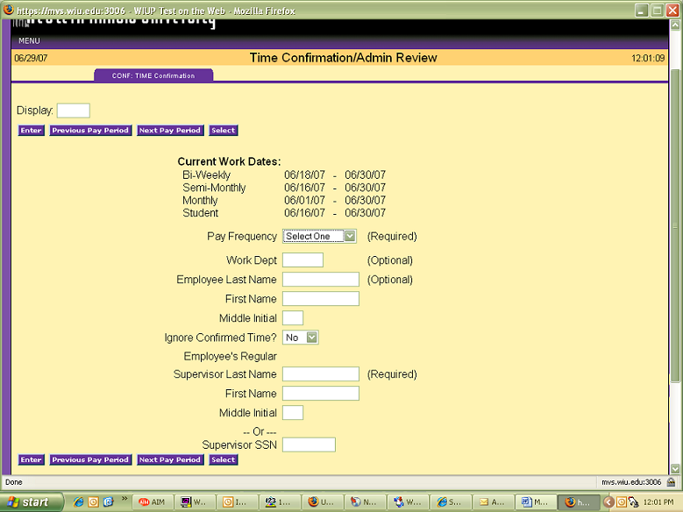

The Monthly Time Reporting screen will be displayed.

After checking that the hours are correct, the supervisor should click on the “Yes” in Supervisor Confirm Box and click or press enter. The supervisor can then click on the “Next Employee” box to proceed to the next employee timecard. When all timecards have been confirmed, the supervisor can click on “Signoff” in the upper right hand corner of the screen.

The Overtime Confirmation by Fiscal Agent option is only to be used when confirming overtime for Bi-weekly employees.

The Review by Office Administrator option can be used by the designated department office administrator to check all the time records for the department. To use this option click on the circle next to Review by Office Administrator. The Time Confirmation/Admin Review screen will then be displayed.

The office administrator should click on Monthly in the Pay Frequency drop down box then enter the Work Dept to check timecards.

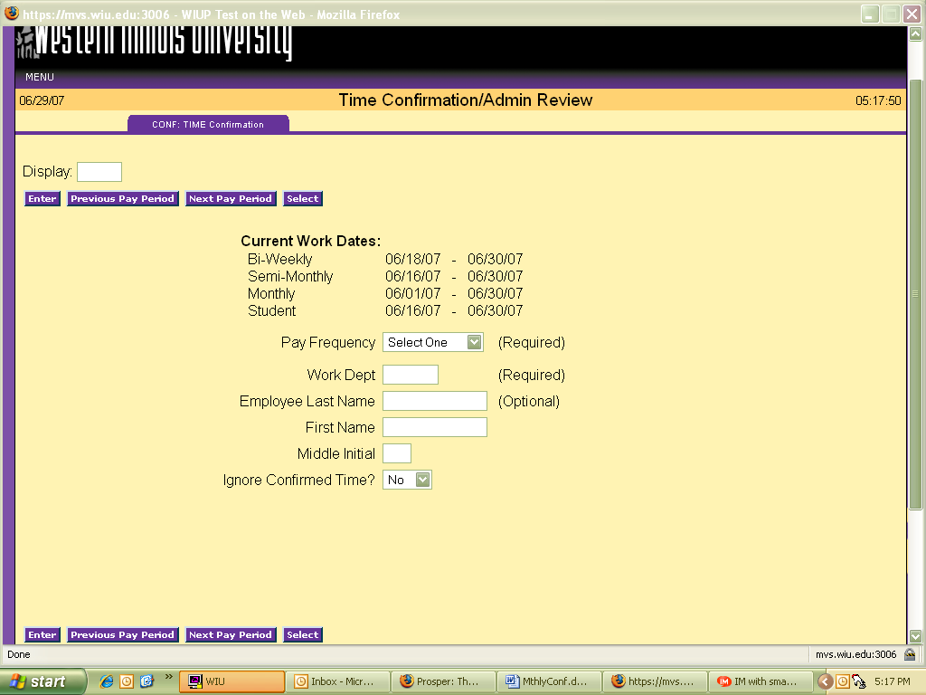

The Monthly Reporting screen will be displayed. The office administrator can then check the timecards to be sure they’ve been confirmed by employees and supervisors.

Confirmation by Alternate Supervisor is used to confirm an employee’s time screen when the employee’s supervisor is unable to confirm the screen. Click on the “Confirmation by Alternate Supervisor” option. The Time Confirmation/Admin Review screen will be displayed.

This will then automatically bring up all employees listed for the alternate supervisor.

For questions concerning the Time Confirmation screens, please contact the Academic Personnel Office at 298-2216 or email the office at AcademicPersonnel@wiu.edu.

11/11/11

