English Language Learner Study Guide

Lesson 1: English Language Learner Demographics, Populations and Language

Topic 1: ELL Demographic and Language
- What percentage of students in IL are English Language Learners?
- Linguistically and culturally diverse students are found in large metropolitan areas as well as in rural schools. True or False?
- According to the Illinois State Board of Education, how many languages are spoken by ELLs other than English at home? Answer: over 144 languages other than English spoken at home
- What are the five states with the highest ELL student enrollment? Answer: CA,TX, FL, NY, IL

Topic 2: Second Language Acquisition
- Name one factor that affects second language acquisition.
- Define first language and second language.
- Name one characteristic that first language learners and second language learners have in common.

Topic 3: Importance of Maintaining & Valuing Heritage Language
- Language is an expression of culture and identity. True or False
- Name the principal adverse effect of losing one's heritage language.
- In our role as teachers, we should ask parents to stop speaking the native language to their child so that they can learn English. True or False

Topic 4: Home-School Connection
- What is one reason parents of ELL students may shy away from making a home-school connection?
- Providing translators for parents of ELLs is not the responsibility of the school. True or False
- Siblings who are minors make excellent translators when there is no one else to translate. True or False

Lesson 2: English Language Populations – It’s a Small World!

Topic 1: Cultural Differences: Don’t Assume…Observe…
- When researching cultures and peoples remember that people are more different as individuals than they are alike as a group. True or False
- What are some ways discussed in this topic in which cultures may differ?
- Flexibility is important when working with students of different cultures as their cultural values may differ from your own. True or False

Topic 2: Spotlight Hispanic Population
- What two terms are labels that are used interchangeably to identify people of Spanish-speaking countries?
- Which of the following countries fit under the label Hispanic?
- Mexico
- Brazil
- Ecuador
- Cuba
- What is the percentage of Hispanic students enrolled in public schools across the nation are United States citizens?

Topic 3: Spotlight Asian Population
- Which of these countries does not fit under the label Asian? India, China, Malawi, Lebanon
- Which are the top Asian languages spoken in IL are:
- Arabic
- Filipino
- Vietnamese
- Cantonese (Chinese)
- Mandarin (Chinese)
- Asian students may experience a bias known as the "myth of the model minority" which perpetuates them as high achieving learners who are happy to be initiated into North American life. True or False
- Asian students can struggle with the same issues that are common to other ELL students; mainly minimal parental academic support, lack of content knowledge needed to function in U.S. school systems, difficulty with English proficiency, having to adjust to new social norms, cultural traditions, and academic settings. True or False

Topic 4: Common Barriers for Hispanics and Asian ELLS
- Name the SIX aspects of language that a second language learner must master in order to become fluent.
- Why might a Chinese ELL student pronounce the word rake as lake?
- Which of these would be a Spanish cognate for the English word family?
- familia
- fantastic
- fabuloso

Lesson 3: Identification, Enrollment and Mandated Yearly Testing of English Language Learners

Topic 1: Federal Laws and State Code
- Which of the following Supreme Court Rulings addresses a school's responsibility to provide a free public education to students regardless of their immigration status?
Multiple choice:
    - Lau v. Nichols (1974)
    - Plyer v. Doe (1982)
    - Castañeda v. Pickard (1981)
- The Equal Educational Opportunity Act of 1974 is a civil rights statute that prohibits states from denying equal educational opportunity to an individual on account of his or her race, color, sex or national origin. Which of these is not consideration in The Equal Education Opportunity Act of 1974?
Multiple choice:
    - race,
    - employment
    - color
    - sex
    - national origin.
- Which state law regulates bilingual education, including services to English Language Learners in IL?
Multiple choice:
    - School Code Article 14C
    - Rules : Section 1.88 AMAOs
    - Rules: Parts 1 and 25 Certification
    - Rules: Part 235 Early Childhood
Topic 2: Enrollment Process for ELLs
- It is the duty of a school to determine the immigration status of a student. True or False
- How many languages is the Home Language Survey translated into? Multiple choice:
    - 12
    - 30
    - over 40
- Scenario: A school has identified the following ELL students: ONE native Japanese speaker, FIVE native Spanish speakers, and ONE native Arabic speaker. Which program are they required by law to have for these ELLs? Transitional Program Instruction (TPI) or Transitional Bilingual Education (TBE)?
- ACCESS testing is only administered once to ELL students. True or False

Topic 3: FAQs About Program Enrollments for ELLs
- All Illinois public schools, including Charter schools, are required to identify and assess Limited English Proficient students (LEPs). True or False
- ELLs will take the PARCC and DLM-AA assessments using appropriate accommodations. True or False

English Language Learner Study Guide

Lesson 4: Instructional Considerations of English Language Learners in the Classroom

Topic 1: A Place to Start – WIDA CAN DO Descriptors
- Which of these states WIDA's mission? multiple choice
- WIDA advances academic language development and academic achievement for linguistically diverse students through high quality standards, assessments, research, and professional development for educators.
- WIDA seeks to create content that educates, informs and inspires.
- WIDA seeks to increase and diffuse knowledge.
- The CAN DO Descriptors help set a tone in your classroom for accommodating the English language learner because they support realistic expectations of the language learner. True or False
- What are the four over-arching communicative purposes of the CAN DO Descriptors? Multiple choice
- who, what, when, where, how
- recount, explain, argue, discuss
- chat, discourse, postulate, lecture
- all of the above

Topic 2: Understanding WIDA English Language Proficiency Standards: A Resource Guide
Use the Word Bank listed below to label the parts of ELP Standard 3: The Language of Mathematics, Summative Framework for Grades 6-8.
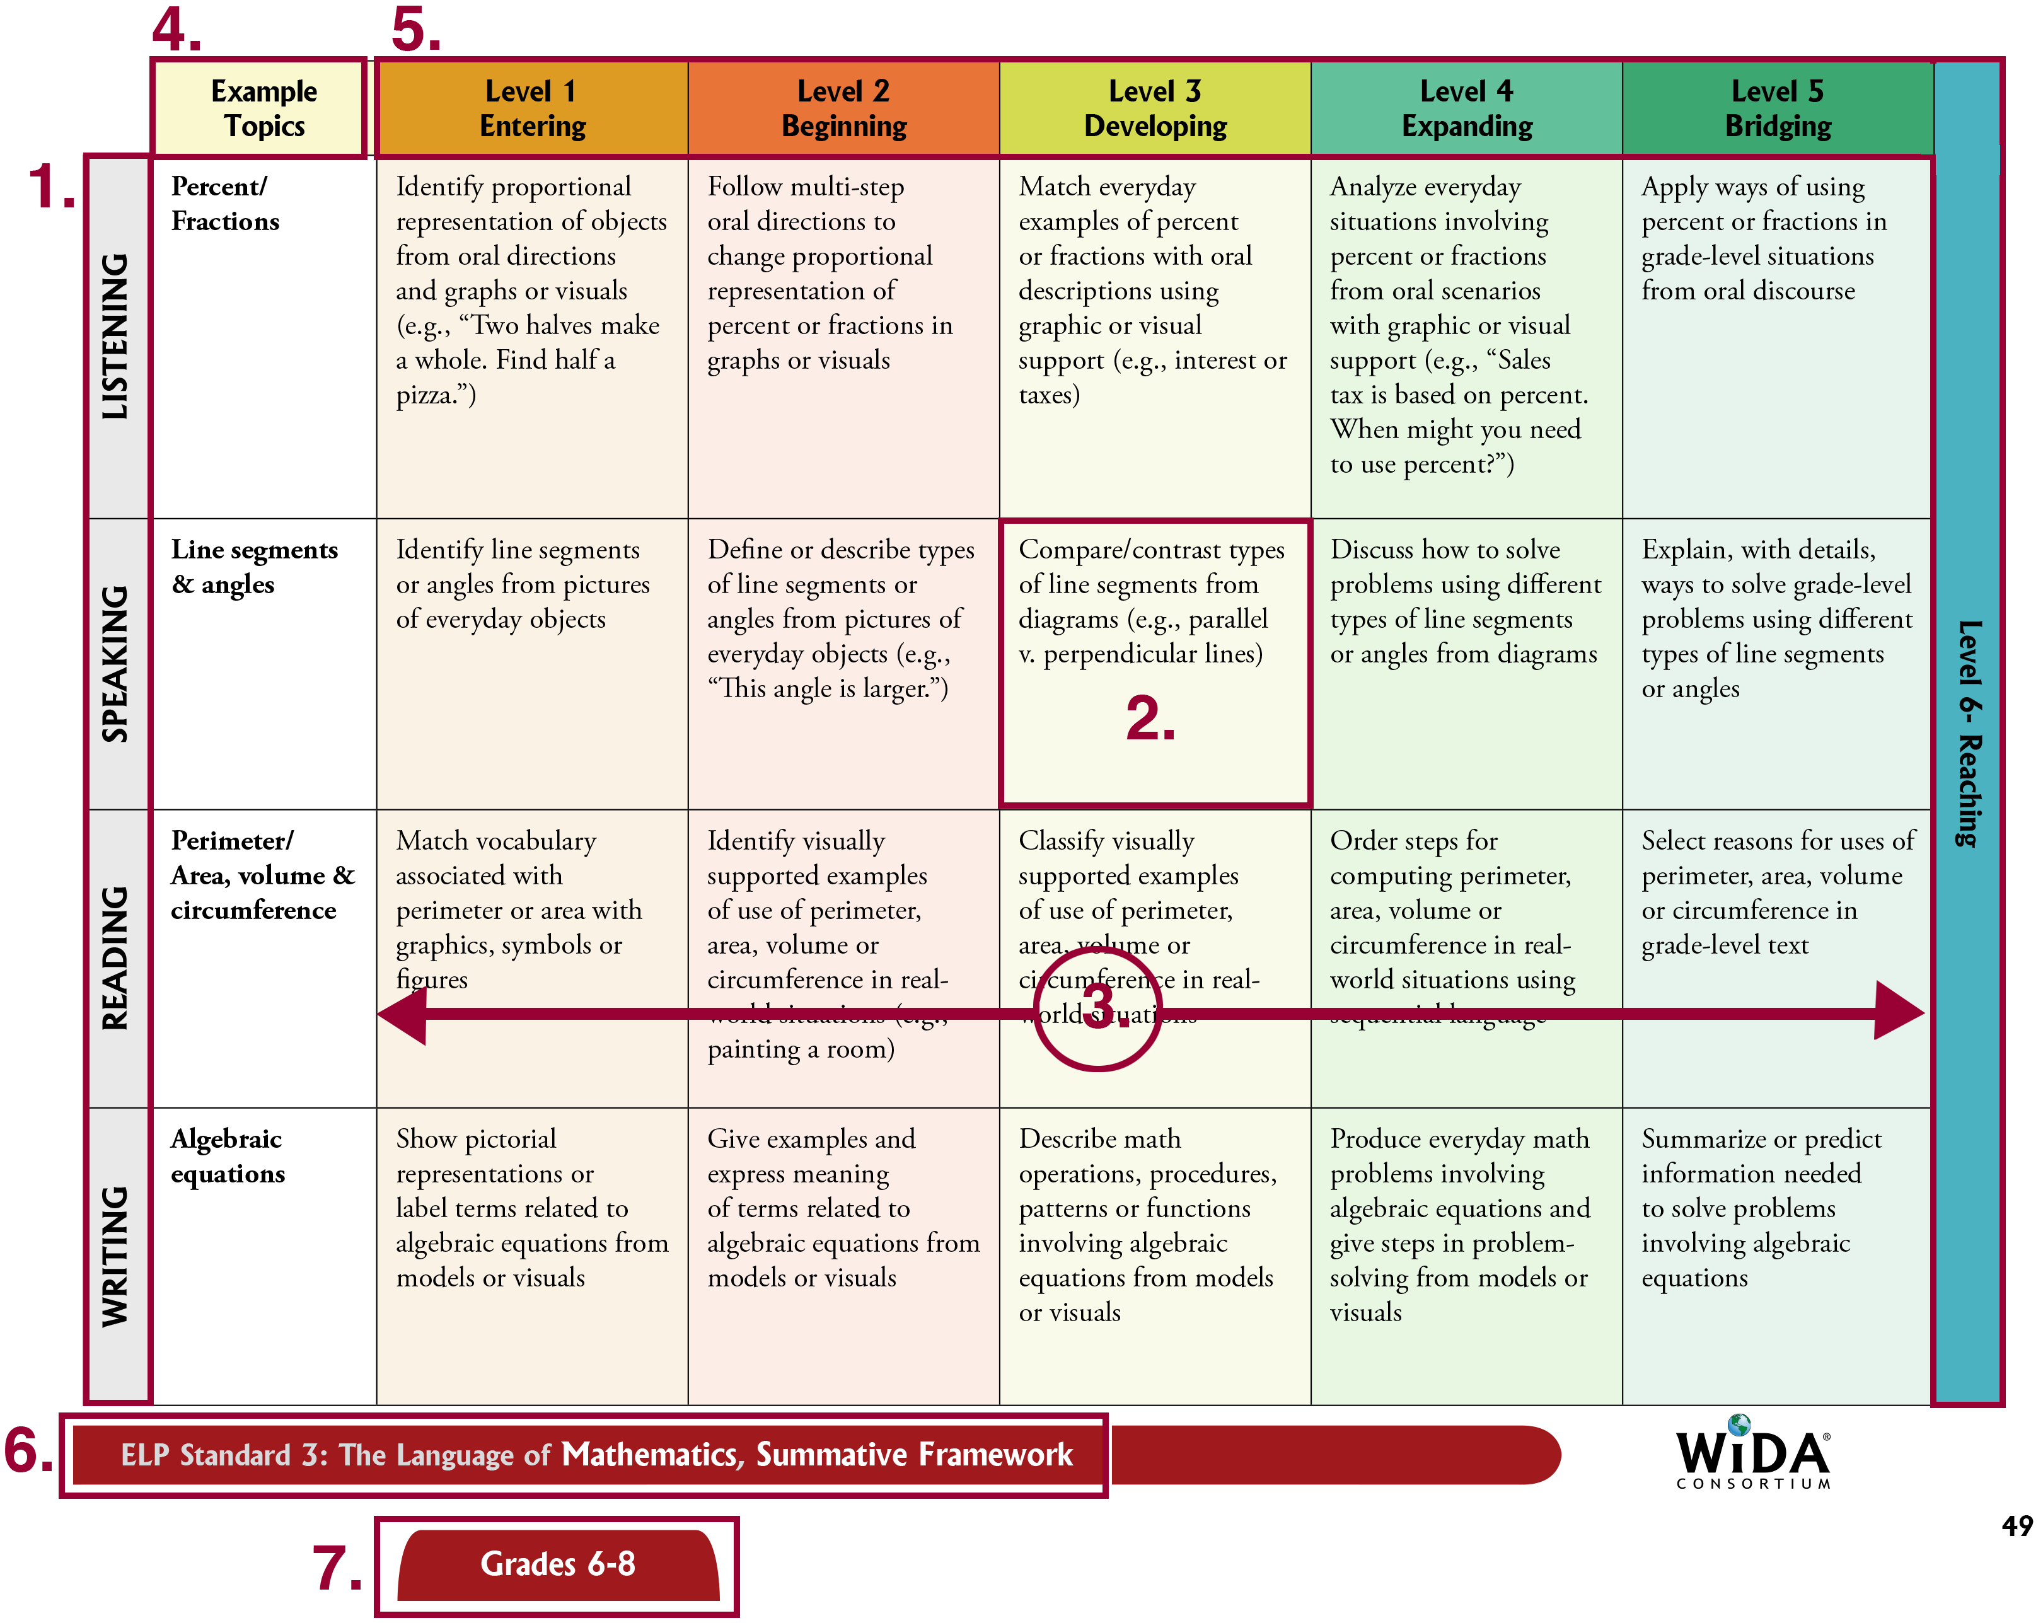
Word Bank:
- Levels of Language Proficiency
- Topics
- Language Domains
- Grade Levels
- MPI (Model Performance Indicators)
- Strand
- English Language Proficiency Standard

Topic 3: A Little Theory You Should Know: BICS and CALP
- True bilingualism can take between 5-7 years. True or False?
- What is BICS?
- What is CALP? Answer:
- Why should academic language be taught in an explicit and meaningful way?

Topic 4: Effective Vocabulary Instruction for ELLs
- List 1 recommendation for effective vocabulary instruction.
- How does Connie Cochran answer the following question: What do ELLs need to become proficient readers in L2 (English)?
- They need to be given an English dictionary.
- They need alone time with the text.
- They need to develop a sophisticated vocabulary knowledge.
- What 4 adjectives does Connie use to describe the type of vocabulary instruction that will result in access to content area curriculum and an increase in academic achievement of ELLs?
- fast, quick, purposeful, gentle
- frequent, intensive, systematic, complex
- periodic, general, traditional, overarching
- none of the above

Topic 5: Sheltered Instruction Observation Protocol (SIOP)
- SIOP lesson plans can only be used for instructing ELL students. True or False
- The idea behind comprehensible input it to make content clear for the teacher. True or False

Topic 6: Effective Vocabulary Instruction for ELLs
- Which of these are supports that can be used in the classroom for ELLs?
- graphic supports
- athletic supports
- interactive supports
- sensory supports
- Name on basic principle of cooperative learning.
- Kagan classroom strategies do not work with all diverse learners. True or False

