Council on General Education
March 23, 2017– 3:30 p.m. – Stipes 501

Spring 2017 CGE Membership
Betsy Perabo Program of Liberal Arts and Sciences (Multicultural)
Keith Holz Art (Humanities/Fine Arts)
P.K. Babu Physics (Math/Natural Sciences)
Darcy Plymire, Chair Kinesiology (Human Well-Being)
Jongnam Choi Geography (Social Science)
Krista Bowers Sharpe Library (At-Large)
Kathleen O’Donnell-Brown English (Basic Skills/Writing)
Jonathan Day Political Science (Social Science)
Steve Bennett Geology (Math/Natural Sciences)
Ute Chamberlin History (Humanities)
Gary Daytner Educational Studies (At-Large)
David Zanolla Communication (Basic Skills/Public Speaking)
Maggie Walsh Student Government Association
Kyle Mayborn College of Arts and Sciences (Ex-Officio, Dean’s Council Rep.)
Nancy Parsons Office of the Provost (Ex-Officio, Provost’s Rep.)
Michelle Yager Advising Center (Ex-Officio, COAA Rep.)

GERC Members
Gordon Pettit Philosophy (Arts & Sciences)
Marty Maskarinec Computer Science (Business & Technology)
Emily Shupe DFMH (COEHS)
Marjorie Allison English (Past Chair, CGE)
Diane Sandage Sociology & Anthropology (Past Chair, CGE)
Cheryl Bailey Communication (Fine Arts and Communication)
Richard Filipink History (CAGAS, ex-officio)

Elected Members Present: Choi, O’Donnell-Brown, Bennett, Chamberlin, Perabo, Plymire, Walsh, Holz, Day, Babu.
GERC Members Present: Maskarinec, Shupe, Allison, Sandage, Bailey, Pettit.
Elected Members Excused/Absent: Bowers Sharpe, Daytner, Zanolla.
GERC Members Excused/Absent:
Ex-Officio Members (CGE/GERC) Present: Mayborn, Parsons.
Ex-Officio Members Excused/Absent: Filipink, Yager.
Guests: Dr. Gregg Woodruff, Angela Lynn.
Chair Plymire called the meeting to order at 3:35 p.m.
Minutes from 3/2 were proposed for approval. Allison moved to approve; Bennett seconded. Yea – 13. Opposed – 0. Abstention – 1. – Minutes approved.
Announcements – none.
Additions to the agenda:
Pettit moves and Holz seconds that we meet again in subcommittees at the end of the meeting – time allowing. 12 – aye; 1 – nay; 2 abstentions. Motion carries.
Pettit move and Perabo seconds that we examine new business first and then old business. 13 – aye; 1 – nay; 2 abstentions. Motion carries.
Reports:
Nancy Parsons –She has received much of the assessment date for fall and will email those department who have not yet submitted data. She also put the enrollment numbers for F16 and Sp17 in the enrollment folder and updated the Gen Ed file to reflect F16 and added Gen Ed Sp17. This info went out in an email to all GERC members Friday, March 24 at 4:25.
Kyle Mayborn – nothing to report.
Michelle Yager – No report/not present.
Faculty Senate/Articulation Requests – no report.
New Business:
Darcy Plymire resigns as chair of GERC effective immediately but is convinced to remain as chair for the remainder of this meeting. No one evinced interest in the position and members are asked to ponder their desire to serve for the next meeting. Perabo moves and Sandage seconds the motion that appointing a new chair be the first item on the agenda for the next meeting. 16 – aye; 0 – nay; 0 – abstentions. Motion carries.
Old Business:
Discussion of Maskarinec’s proposal for the reorganization of general education (document attached.)
Salient points from discussion of March 23rd –
• Our job as faculty is to identify what we believe is the best education for our students.
• The state mandates that all universities have a multi-cultural component in general education; we have chosen to make it an important point of our general education.
• As we are encouraging the transfer of students from other states, it is more difficult to evaluate students’ transcripts. Suggestions were made as to allowing students to show proficiency in multi-cultural through a test or activity or to allow leeway for between state transfers.
• Change is difficult because each area wants to protect their piece of general education because of their belief in its value. Small group discussions may not suggest changes but a large group discussion would do so.
• Advisors say that it is almost impossible to finish a degree without taking an FLGI course within majors or through General Education so is it necessary to have a separate FLGI requirement? FLGI options are decided within majors.
• University 100 was placed into General Education because of comprehensive majors.
• Many benchmark and peer institutions have some emphasis on multi-cultural/international courses. In an increasingly global culture, it is good for students to have this information.
• Other schools claim to incorporate multi-cultural in their gen ed courses and do not have separate designations. (Sort of like our elimination of writing intensive courses and our stress on incorporating writing in ALL gen ed courses.)
• Some students have learning disabilities in math. Could the math requirement be changed or fulfilled with a quantitative reasoning course?
• Students are very concerned with mental health issues. Could a model be developed which includes intellectual health and personal development? Should we focus more on human well being? With only 3 hours required (one of which is University 100) there is little room for financial, mental, and physical health courses.
• Dr. Woodruff presented documents for the committee and stressed that students who take the course have better financial health. (Documents are attached to the end of the minutes.)
• Natural sciences is still concerned that the number of hours in their area not be reduced and continue to believe students are best served by a face-to-face lab class as opposed to an online lab class.
• Does CGE/GERC wish to totally reorganize gen ed or to target the main points of concern: MC/FLGI requirements/overlap; the human well being category hours and requirements; online science courses; math course sequence; number of courses in general education/reduced number of students; courses in deep freeze/resurrection of courses.
Meeting adjourned at 5:13 p.m.

New General Education Category Proposal
Proposed by Martin Maskarinec

Category 1) University Exploration 1 hour
Category 2) Communication 9 hours
a) Writing and Composition (6 hours)
b) Public Speaking (3 hours)
Category 3) Natural Science and Mathematics 10 hours
a) Quantitative Reasoning (3 hours)
b) Natural Science (7 hours) to include at least 1 lab
Category 4) Humanities 9 hours
a) Visual and Performing Arts (3 hours)
b) Human Questions and Contexts (3 hours)
c) Cultural Exploration – Humanities (3 hours)
Category 5) Social Sciences 9 hours
a) American Experience (3 hours)
b) Global Experience (3 hours)
c) Cultural Exploration – Social Sciences (3 hours)
Category 6) Wellness 2 hours
To include physical, emotional, intellectual, financial well being
Observations/Additional Comments:
• No course may count in more than 1 category. This makes the category requirements as described above easy to follow (no multi category courses, no “only two from one department” rules to complicate a student’s understanding of the requirements.
• FLGI goes away – no “starred” classes that need to be taken in addition to the base category requirements.
• Some leeway would need to be granted for transfer students.
• I would recommend limiting a department/unit to 3 times the hours needed to meet a requirement. In other words, if the requirement is 3 hours, an individual department/unit may only offer 9 hours of courses to meet this requirement.
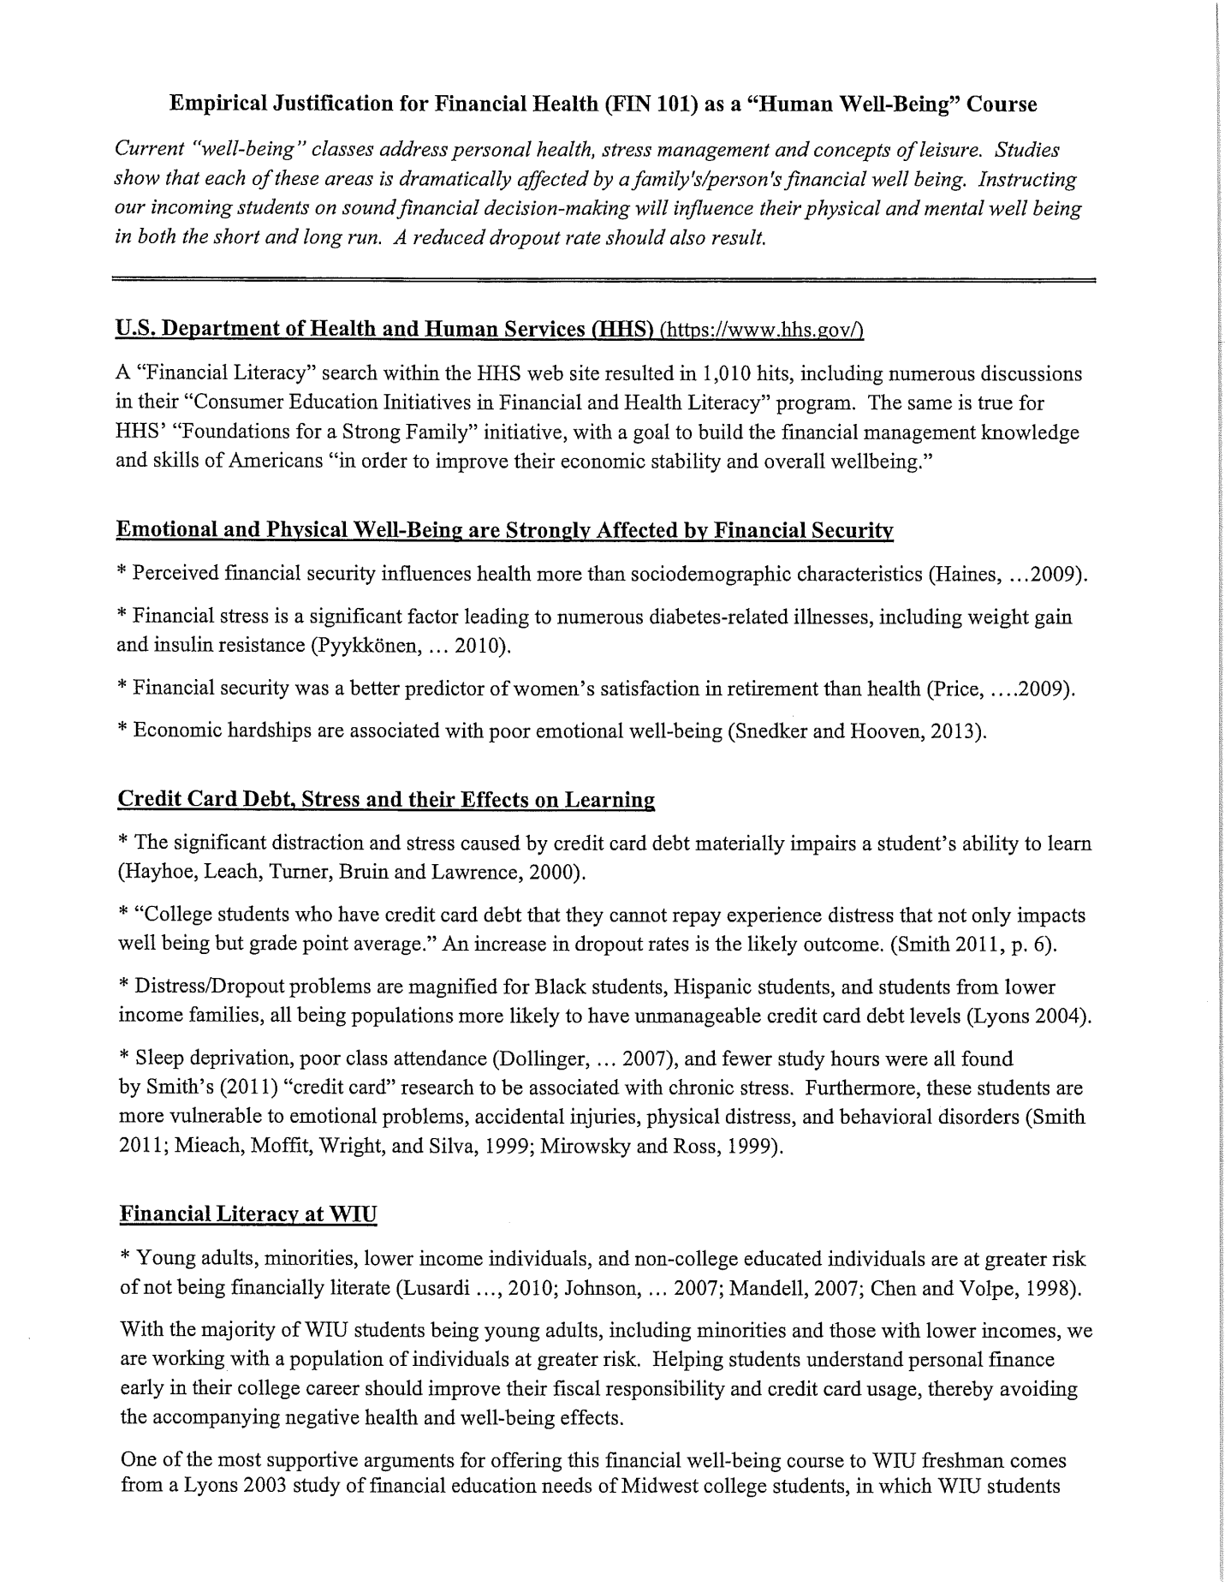
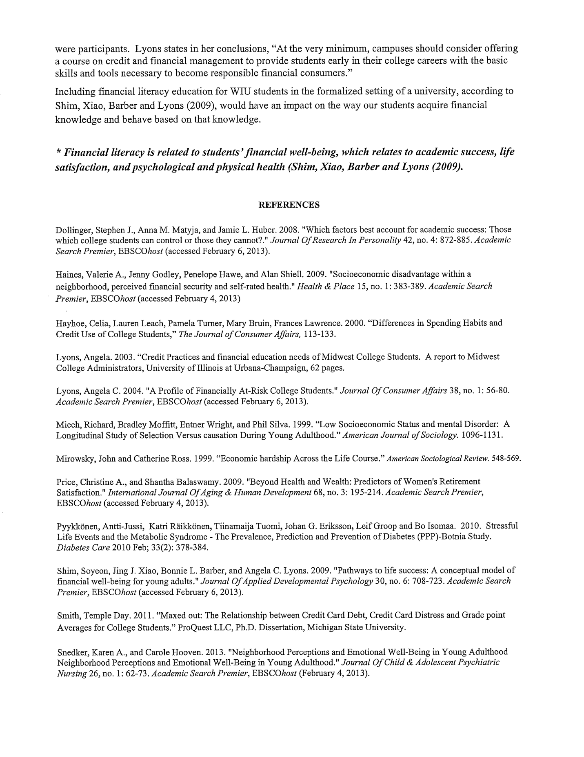

Summary of Assessment Results for FIN 101 for CGE
After being developed as a General Education course related to health and well-being, FIN 101 (Financial Health) was first offered in the fall semester of 2014. Considering the level of student success in the course and its obvious, practical importance to one’s financial and emotional health, it is no surprise that FIN 101 has proven to be so popular. Being aware of the strong, direct correlation between the successful, management of one’s personal finances and feelings of well-being, the faculty of WIU’s Department of Accounting & Finance are particularly proud to support the emotional health and financial success of our students by helping them to master the basics of personal finance.

In the first year the course was offered (2014-2015), 159 students registered for FIN 101, and 68% of those met or exceeded the performance benchmarks established by finance faculty members for General Education Goal #2. Another 14% minimally met the faculty’s expectations. In other words, only 18% fell below performance benchmarks on the myriad tasks required to demonstrate their competency on course objectives related to Goal #2. Students achieved even better success on course objectives related to General Education Goal #6. Only 10% fell below expectations, while 73% met or exceeded expectations, and another 17% minimally met expectations.

In only its second year (2016-2017), FIN 101 enrollment nearly doubled to 311 students, and we observed significant improvements in student outcomes as faculty refined their instruction to better fit student needs. On course objectives related to General Education Goal #2, 79% of students met or exceeded performance goals/expectations, and another 14% minimally met expectations. Despite achieving great results in the previous year, students also improved on course objectives related to General Education Goal #6. Only 6% of students fell below expectations, while 84% met or exceeded expectations, and another 10% minimally met expectations.

We continue to be astonished by the success of FIN 101 students in its third year. Since the fall semester is now behind us, we are delighted to report that 142 students completed FIN 101 during fall 2016, despite the enrollment challenges faced by the University. Even better, the success rates continue to climb. During the fall semester, 84% of students met or exceeded expectations for General Education Goal #2 with another 11% minimally meeting expectations. As for Goal #6, 87% of students met or exceed expectations, with another 9% minimally meeting expectations.

To reiterate, over the 2.5 years in which FIN 101 has been offered, 612 students have taken the course, and only 9% and 6% have failed to meet expectations for learning objectives related to General Education Goals #2 and #6 respectively. Furthermore, there has been a monotonic increase in the percentage of students meeting or exceeding expectations since the incipience of the course. The faculty are very proud of the Department’s contribution to the present and future health and well-being of WIU’s student population.

