CCPI Curriculum Workshop
September 19, 2019, 3:30 p.m.
Horrabin Hall 1/QCC 1102
What is CCPI?
CCPI is the Council on Curricular Programs and Instruction and is a subcommittee of the Faculty Senate. MOST undergraduate curricular requests are heard by CCPI, which makes recommendations to Faculty Senate about approvals to changes. The chair of CCPI attends Senate meetings, speaks to the Senate about CCPI decision making, and is another voice for your curriculum changes at this larger body.
What is the Curricular Process?
To a certain extent, this depends on the college that you are in. After being developed in the departments, curricular requests go through the following processes before coming to CCPI:
College of Arts & Sciences proposals go to the College of Arts and Sciences Associate Dean, who, working with the CAS curriculum council, hears the requests and makes suggestions for changes. Following this, requests are heard by the CAS Faculty Council, then returned to the dean for signature before going to CCPI.
Department → Associate Dean/CAS Curriculum Council → Faculty Council → Dean → CCPI
College of Education and Human Services has an Undergraduate Academic Affairs Committee (UAAC) that meets two Fridays a month. The curriculum committees from each school/department submit approved requests to UAAC for approval. UAAC is made up of a faculty representative from each of the schools/departments.
All teacher education related program changes (from any College at the University) must be heard by the University Committee for Education Preparation (UCEP) before going to CCPI.

Departmental Curriculum Committee → UAAC → UCEP → Dean → CCPI
College of Fine Arts and Communication has an Undergraduate Curriculum Committee that meets on an “as needed basis.” From the curriculum committees from each department, approved requests are heard by the college committee, which is made up of a faculty representative from each of the six departments. The COFAC Dean’s Office calls meetings when there is a need.
Departmental Curriculum Committee → College Curriculum Committee (called by Dean) → Dean → CCPI
College of Business and Technology requests are heard by the Curriculum Committee and then signed by the Dean or Associate Dean.
Department → College Curriculum Committee → Dean/Associate Dean → CCPI
THEN
Once the Dean/Associate Dean approves a proposal, the proposal can be heard by CCPI. Further, if the course needs approval as a Gen Ed, Global Issues (GI) or Writing Instruction in the Disciplines (WID) course, it can be heard by the appropriate councils (CGE, CIE, and WID) all at the SAME TIME it is heard by CCPI. A course request can go forward if it fails to get CGE, CIE, or WID approval. It cannot go forward without CCPI approval. The Faculty Senate Office Manager will check with the other councils to see where the request stands with the others prior to going up to Senate.
Once a proposal is approved through CCPI and any necessary changes have been made, it will be heard by Faculty Senate, if applicable. (For example, CCPI reviews experimental courses for informational purposes, but these are not heard by Senate). The Chair of CCPI attends Faculty Senate meetings and a representative from the department must also attend. Senators may have questions that a department chair or other faculty representative can answer if that person is in attendance. Finally, the Provost sees the request and gives final approval.
What Does CCPI See?
The forms that CCPI sees are mainly those found on the website. CCPI members also see the letters of approval from other departments. CCPI does NOT need the course syllabus, unlike some other groups (for example, CIE wants to see syllabi for GI courses to make sure that they meet criteria). Less information sometimes works better for you.

Academic Terms
Degree (120 s.h.; transcripted)
A title conferred on graduates as the result of having completed University requirements for that degree.
Approvals: Feasibility Study (Provost), CCPI, Faculty Senate, Academic Vice President, WIU Board of Trustees, IBHE

Core
A core is a set of required courses. In a major, the core shall be common to all versions of a major, regardless of option, emphasis, or track.

Comprehensive Major (48-66 s.h.; transcripted)
At least 48 semester hours and includes at least 15 s.h. outside the major discipline within the degree.
Completion of a Minor is not required.
Approvals: Feasibility Study (Provost), CCPI, Faculty Senate, Academic Vice President, WIU Board of Trustees, IBHE

Non-comprehensive Major (32 s.h. to 47 s.h.; transcripted)
Includes specific course requirements unique to a broad field of academic specialization and may include elective courses.
May be limited to a specific academic department or may include specified courses from more than one academic department.
Requires completion of a Minor as part of the degree program.
Approvals: Feasibility Study (Provost), CCPI, Faculty Senate, Academic Vice President, WIU Board of Trustees, IBHE

Minor (16-24 s.h.; transcripted)
Includes specific course requirements unique to a minor field of study and may include elective courses.
May be limited to a specific academic department or may include specified courses from more than one academic department.
Approvals: CCPI, Faculty Senate, Academic Vice President

Concentration (37-47 s.h.; transcripted)
Approved set of courses limited to the Interdisciplinary Studies Major.
Integrates two or more academic disciplines to develop an area of study.
Does not replicate an existing major.
Approvals: Feasibility Study (Provost), CCPI, Faculty Senate, Academic Vice President

Emphasis (Number of hours determined by Department; not transcripted)
Approved subset of courses within a Major.
Approvals: CCPI, Faculty Senate, Academic Vice President

Option (1/3 – 3/4 of the total hours for the major; transcripted)
Subdivision which provides greater specificity within a major academic field of study.
Includes a set of required courses in addition to those specific courses required for the major.
May include elective courses.
For majors that have options, the core requirement shall be met as follows: a) non-comprehensive majors will have at least 9 s.h. of unique required courses; and b) comprehensive majors will have at least 12 s.h. of unique required courses.
All options within a single major will have the same core.
Approvals: Feasibility Study (Provost), CCPI, Faculty Senate, Academic Vice President

Track (Number of hours determined by Department; not transcripted)
Informal subset of courses handled through advising.
Approvals: None

Certificate of Undergraduate Studies ( 30-60 s.h.; transcripted)
An approved specific set of upper-division undergraduate courses focused around an interdisciplinary- or single discipline-specific theme.
Does not replicate an existing major or minor.
Must have successfully completed a bachelor’s degree for certificate to be transcripted.
Approvals: Feasibility Study (Provost), CCPI, Faculty Senate, Academic Vice President

CCPI’s Website
The website will give you the dates of your CCPI meetings and deadlines. It also has some links that you will find vital for the curricular process, definitions of terms, policies and procedures for CCPI, and sample verbs to use for course objectives.
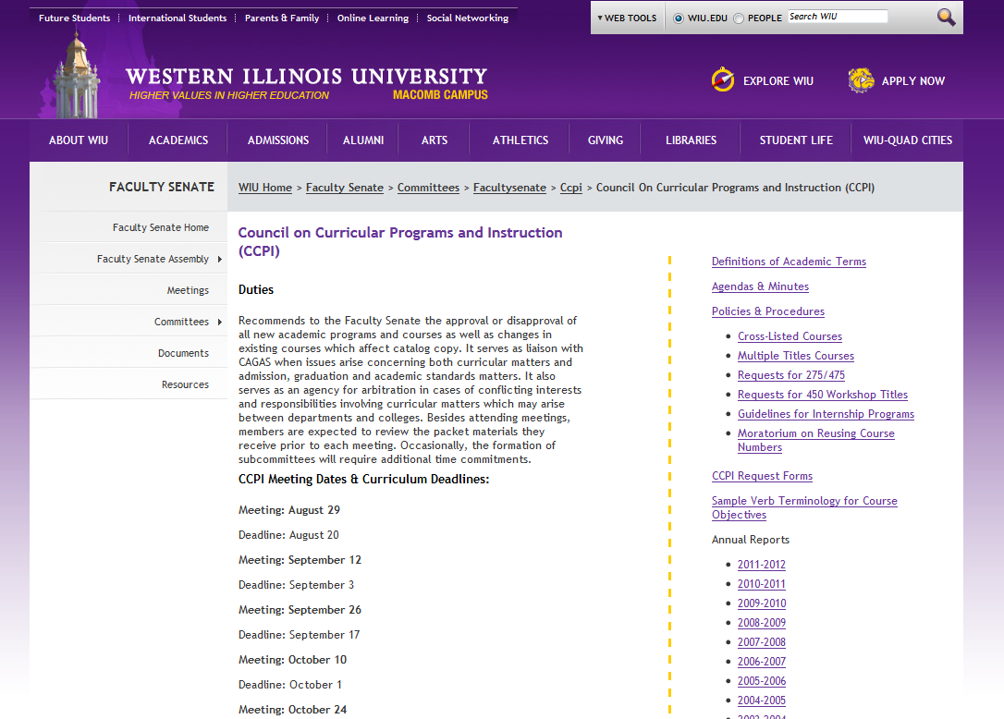

CCPI Request Forms
There are a lot of different versions of the forms floating around. The CCPI website has the most recent versions, which are the ones that you should use. Most of the forms you will need for your curricular requests are found in here; others can be found on the Provost’s website.
The most common forms CCPI sees are:
- New Course Request
- Change of major/minor
- Request for change in existing course
Tips for All Forms
Gray Box
For each of the forms, the gray box has a general description for what is being requested, such as Request for New Course or Request for Change, but departments can add to this, such as “Request for Change in Course Description and Prerequisites.” Be sure to include the course prefix and number (e.g., UNIV 390) or title of the program (e.g., Minor in Mathematics), as well.
Remove Directions
Remove any instructions in italics once the form is completely filled out.
Remove Sections
Sometimes there are whole parts of a request form that don’t apply to you, specifically on the Multipurpose Request for Change form. You can remove those parts.
Match the catalog
A lot of times people will change old forms that they have saved. These old forms may not reflect the current state of your department. Make sure to check any old form that you may be using as a template with the catalog (available online at http://www.wiu.edu/catalog/) before sending it up.
Check with All Other Departments
It’s easy to forget that changes in your own department can affect other departments. If your proposal overlaps the course content of another department, you should send an email to the chair of that department asking for them to review your proposal and requesting a letter of support.
When to check?
- You are offering a course that is/could be seen as multidisciplinary in nature
  - Check key words of the course content against the undergraduate catalog
- You are changing prereqs that will shift enrollment in another department’s courses
- You are changing major requirements that could impact enrollment in another department’s courses
- You are changing your major or course offerings in ways that may affect other departments that require your classes
- You change the name, number, description, etc. of a course required by another major
- You want to add a required course in another department. You need to make sure that they can provide coverage.
- Some courses, such as internships, may not need this level of checking.
Some of these instances may be simply the process of discussing the issue with the other department, no letter needed. But a rule of thumb is ALWAYS TO PAUSE AND CONSIDER – who could be affected by this, in what way, at all.
Request for New Course
Prereqs: Consider if you want them consistent with your existing courses. Follow the formatting of how the other prereqs in your department appear.
Course objectives: these need to be measurable action items. To help you, CCPI has a list of verbs that you can use to start your course objectives (http://www.wiu.edu/faculty_senate/committees/facultysenate/ccpi/Sample%20Verbage%20for%20Course%20Objectives.pdf).
Letters of support: Search through the course catalog for key terms that will be covered in the course. From there, compile a list of possible cross-overs and email all those department chairs. This is not a perfect process. Part of the lower level of the curriculum proposal process helps you to identify other departments.
Change of Major
Living Document: First, you need to make sure that your document matches up with the course catalog. But, beyond that, you need to make sure that your document matches up with the reality of what has happened within the curriculum for your department during that catalog year. So, if you changed the name of the course in October, in March your change of major should show both the old name of that course (in the existing column) and indicate the new name that was passed (in the proposed column). This is because most of CCPI and Senate only have the old catalog to look at. Yet the people who actually PUT IT IN THE CATALOG deal with the living document. Make it easy. Include both.
This makes it essential that someone in your department keeps track of the current state of affairs with your curriculum.
Other ways to clarify your change of major form:
- Use SAME in the Proposed column when there are no changes.
- Line-up changes between the Existing and Proposed columns so that existing and new are on the same line/row.
- Bold changes.
Request for Change
Make sure to add details to the gray box and delete extra info that’s not needed. If you are not changing the title, delete that section.
You don’t have to send all changes through CCPI. (See “What Doesn’t Need CCPI Approval” below.)
What Doesn’t Need CCPI Approval?
- changes in course numbers WITH THE EXCEPTION of changes from lower to upper division or from upper to lower division;
- changes in course titles;
- minor changes in specified course content and objectives. (These might include but are not restricted to nomenclature and changes that do not increase course content or expand objectives.);
- minor changes in requirements for a major, minor, option, concentration, emphasis, or certificate of undergraduate study which do not change the core, specify required general education courses, or result in a net increase in the number of required hours in the program. (This might include but would not be restricted to changing courses included in directed electives.);
- changes in course prerequisites WITH THE EXCEPTION of requests for new and increased prerequisites. (These might include but would not be restricted to deletion of a prerequisite; permission statements, e.g., permission of instructor required; or change in prerequisite that stays within the same department/school/unit, upper or lower division and semester hour range.);
- dropping of courses no longer needed;
- change in course prefixes.
If you aren’t sure, ask the Provost’s office (Linda Prosise, 8-2110) to help you with this. There is also a list of these changes on the Provost’s web site under the curriculum tab.
Important Dates
CCPI meetings are held at 3:30 in Horrabin Hall 1. A teleconference connection to WIUQC or zoom access is provided as needed upon request.

FALL 2019 SPRING 2020

September 26 January 23
October 10 February 6
October 24 February 20
November 7 March 5
November 21 March 26
April 9
April 23

FALL 2020 SPRING 2021

September 3 January 28
September 17 February 11
October 1 February 25
October 15 March 11
October 29 April 1
November 12 April 15
December 3 April 29

