Absence Leniency Guide for Faculty

Background
Absence leniency is an accommodation that is recommended most often in cases where students have conditions that may cause them to be absent more often than their peers. Absence leniency means that the student will not be penalized for absences within reasonable limits beyond what the course attendance policy allows. It is possible that a student’s performance on assignments and exams may be directly impacted by absences; however, a student with this accommodation should not lose points solely based on absences. Also, students with this accommodation should only provide documentation to Disability Resources regarding appointments and hospitalizations.
While absence leniency is approved on a case‐by‐case basis by Disability Resources and depends on each student’s individual circumstances, the degree of leniency is decided by faculty, in consultation with Disability Resources, on a course‐by‐course basis. The nature of the course determines the extent of flexibility with absences. Because professors are the content experts, they are best situated to assess their courses to determine the extent to which leniency can be granted. To assist faculty with this course analysis, Disability Resources created this Absence Leniency Guide.

Limits on Absence Leniency
While faculty are encouraged to be flexible in the implementation of absence leniency, there are limits to this accommodation.
- This accommodation may not be permissible where class attendance or participation is an essential component of the course. If this is a lab, performance-based, internship, or practicum course, please consult with Disability Resources as accommodations may not alter the essential components of the course.
- While it is reasonable to go over some of the missed materials with students during office hours or by appointment, faculty are not expected to re‐teach the course to students who cannot attend the lectures.
- Professors are not expected to reconstruct courses entirely. For example, a course that is a lecture‐style course, does not need to be reconstructed as an independent study or an on‐line course.
- Professors should not lower course standards or make courses easier for students who cannot attend.
- Unlimited and excessive absences are not reasonable
- Use of this accommodation for other reasons, including health matters not on record at Disability Resources, seasonal colds and flu, or other non-health related reasons is not acceptable

Communication and Documentation
It is often difficult to give students an exact number of how many absences will impact their educational experience up front. Therefore, regular communication with the student regarding absences and progress is recommended. At the very least, Disability Resources recommends an initial meeting to develop a plan for absences and a follow‐up meeting or email communication if a student is nearing a critical point with absences, and then a final meeting or email once the student has reached a point at which their educational experience is compromised.

Initial Meeting: During the initial meeting, faculty should discuss the nature of the course, the limits of absence leniency (if any), the plan for absences, and how the student needs to communicate them. Faculty and students should use the Plan for Absence Form to document the absence plan.

Follow‐Up Meeting/Email Communication: This meeting may only need to occur if the student has missed several classes and there is a concern about them missing additional classes. During this meeting, it would be important to express concerns, discuss any missing or future assignments/exams, discuss current grade, discuss future class dates of specific importance, gauge student’s feelings about course progress and set limits if necessary. A face-to‐face meeting is preferred, but an email or phone discussion will suffice.
Final Meeting: This meeting is only necessary if the student is in danger of not being able to complete the course with a passing grade and it is believed that absences have contributed to this. This may happen after the last day to drop classes. In this case, faculty may refer the student to CAGAS and may wish to write a letter to CAGAS on the student’s behalf.
Documentation: We suggest you keep a copy of the Plan for Absence Form. Consider emailing the student a brief summary of what was discussed to serve as documentation for both you and the student and can help to ensure all parties are clear as to what occurred. The completed form should be sent to disability@wiu.edu to be kept in the student’s accommodation file.

Many studies indicate an absence rate of 20% is the point at which absences make learning and passing classes more difficult to attain. We’ve provided a chart for easy access when considering absence leniency terms. *Depending on your course, it could be less or more than 20% as the tipping point*
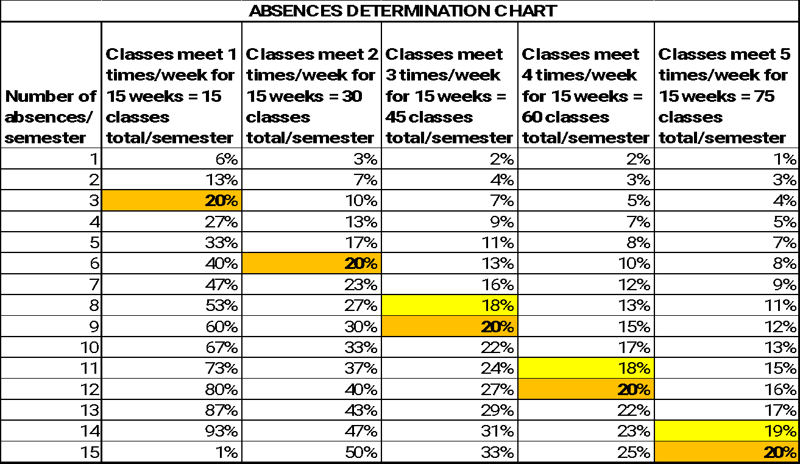

Course Analysis
To assist faculty in evaluating the appropriate extent of absence leniency, the following tool is provided.
Please choose one of the following descriptors to answer each of the questions below:
- Very Little: This is a lecture‐style course, where students read the text‐book, listen to lectures and take notes, complete out‐of‐class assignments, and take quizzes/exams.
- Some: This course is mainly lecture, but may involve some in‐class discussion, student presentation, field trip or other hands‐on experience that is important to the learning objectives.
- About Half: Half of this course is lecture and half is experiential or discussion‐style and/or a good portion of the learning is based on knowledge of concepts previously taught in the course.
- Most: Most of the class is experiential, involves in‐class group work and/or discussion and/or builds on previously learned concepts.
- All: This descriptor is reserved for lab‐style or performance-based courses, practicums, and internships.

- Is there a significant classroom interaction between the instructor and students (e.g., significant discussion, observation and feedback on performance provided, etc.). ________________

- Is there a significant classroom interaction among students (e.g., peer review, discussion, in-class group work, etc.)? Note: Most question-and-answer interactions that occur during lecture style courses do not constitute significant interaction. _____________________________

- Do student contributions constitute a significant component of the learning process (e.g., regular student presentations, discussions, group work, etc.) ________________________

- Does the fundamental nature of the course rely upon student participation as an essential method for learning (i.e., labs, internships, hands‐on experiences)? ___________________

- To what degree does a student’s absence constitute a significant loss to the educational experience of other students in the class? ________________________________________

- To what degree does course material build on concepts previously taught in this course (e.g., math courses where more advanced problem solving depends on the learning of basic math concepts taught earlier in the semester)? __________________________________________

Disability Resources Recommendations
The information below is general guidance that is not based on specific knowledge of your particular course. If you have questions, I would encourage you to contact the DRC after you’ve completed your analysis.
COURSE ANALYSIS RECOMMENDATIONS
Number of answers | Very Little | Some | About Half | Most | All
1 | A | A | A/B | C | C/D
2 | A | A | A/B | C/D | C/D
3 | A | A | B | D | D
4 | A | A | B | D | D
5 | A | A | C | D | D
6 | A | A | C | D | D
A - You should exercise a great deal of leniency. Limits of leniency should be determined by student performance in the class. Students should be advised according to the manner and availability of making up missed work.
B - Leniency is recommended when it does not interfere with learning objectives. Extent of leniency may be based on a combination of which experiences are missed, whether those experiences can be learned at an alternative time or through an alternative assignment, and student performance. Certain experiences may be weighted more heavily than others.
C - The student needs to have a plan for minimal absence leniency; i.e. how are assignments made up or alternate assignments? Consideration should be given to whether or not students have the opportunity to make up missed experiences in other sections or through alternative assignments.
D - Absence Leniency may not be appropriate for this course
*If your ratings fall with some in one very disparate area than another ( i.e. 4 very littles and 2 alls), you are the best judge as to what kind of leniency would lead to the best outcome for the student. The best rule of thumb is to grant leniency based on the most impactful ratings in your course.

